**Credit Card Data Analysis**

# **Project Description:**

To leverage Azure SQL Database and Azure Data Studio to perform comprehensive data analysis on credit card usage, customer demographics, and financial metrics. The objective is to gain actionable insights that can help the financial institution improve customer satisfaction, manage risks, and optimize their credit card offerings.

**Business Requirements:**

1.Count the Number of Customers

select COUNT(distinct client_Num) as Total_customers from Credit_card;

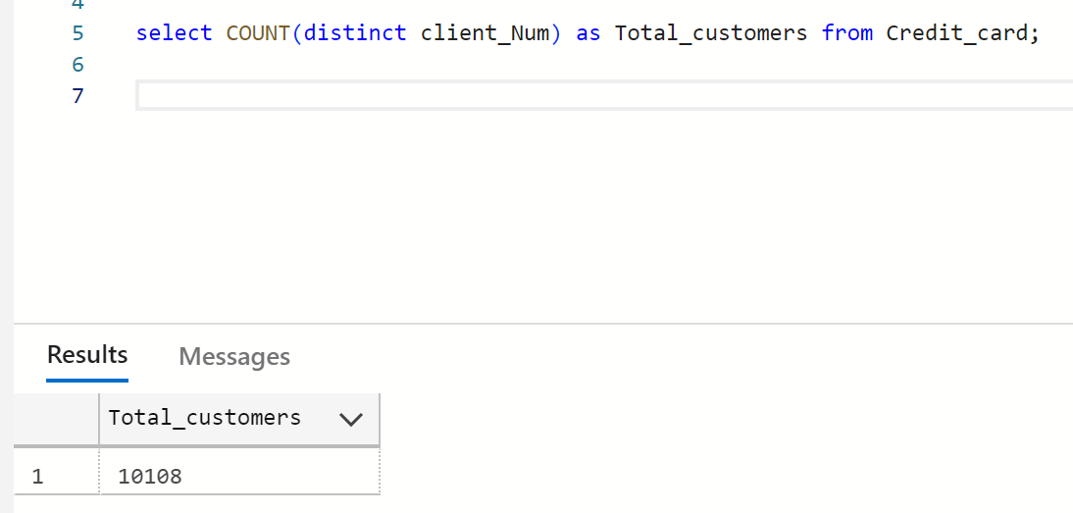

2.Customers Distribution by Card Categories

select card_category, COUNT(distinct client_Num) as Total_customers from Credit_card group BY card_category;

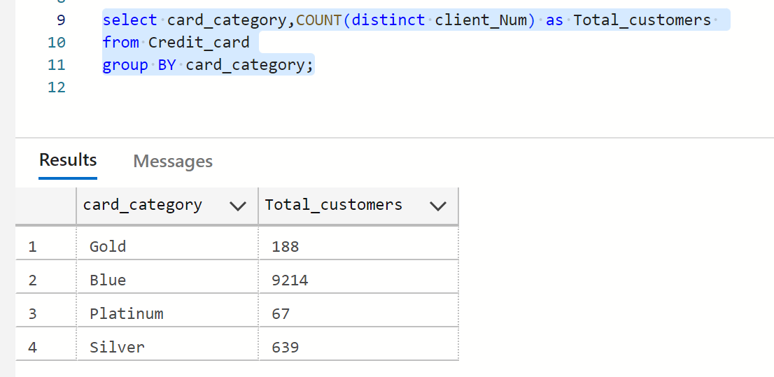

3. Average Annual Fees by Card Category

select card_category, AVG(Annual_fees) as Avg_Annualfee from Credit_card

group by card_category;

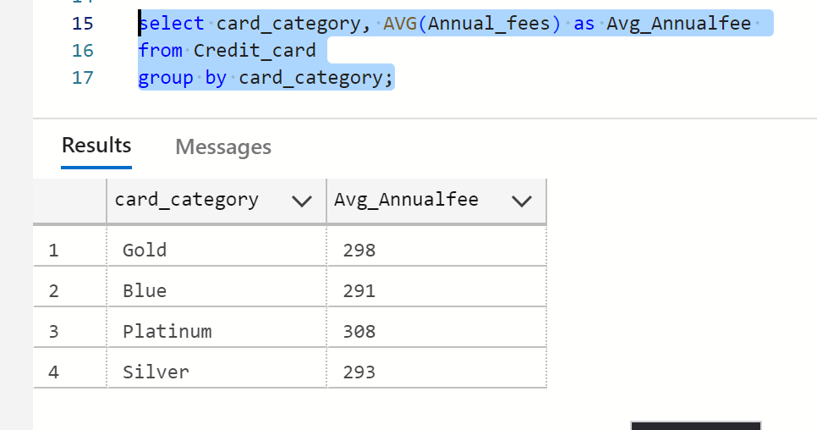

4. Total Interest Earned by Card Category

select card_category, Round (SUM(Interest_earned),2) as Total_Interest_earned from Credit_card group by card_category;

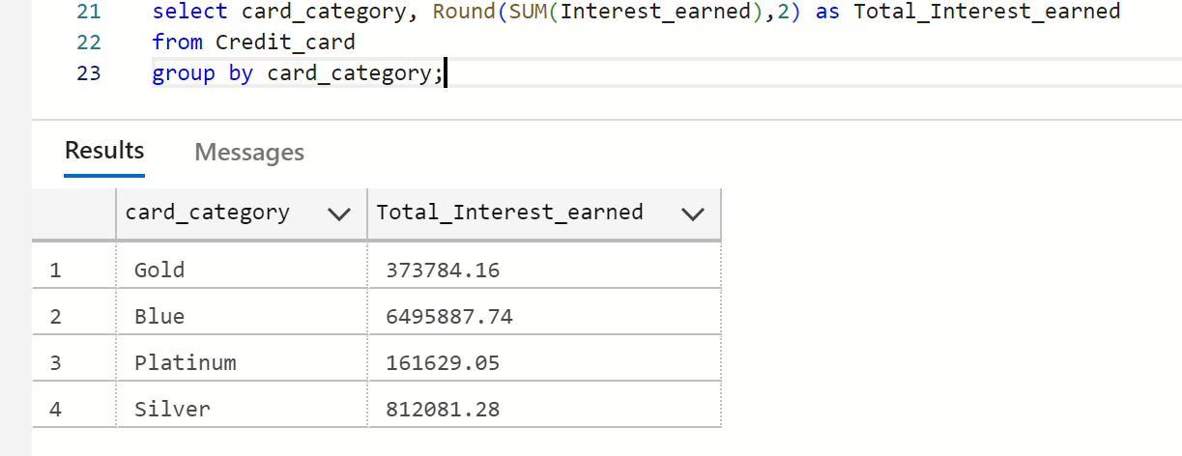

5. Average Utilization Ratio by Card Category

select card_category, ROUND(AVG(Avg_Utilization_Ratio),4) as Avg_Utilization_Ratio from Credit_card group BY card_category;

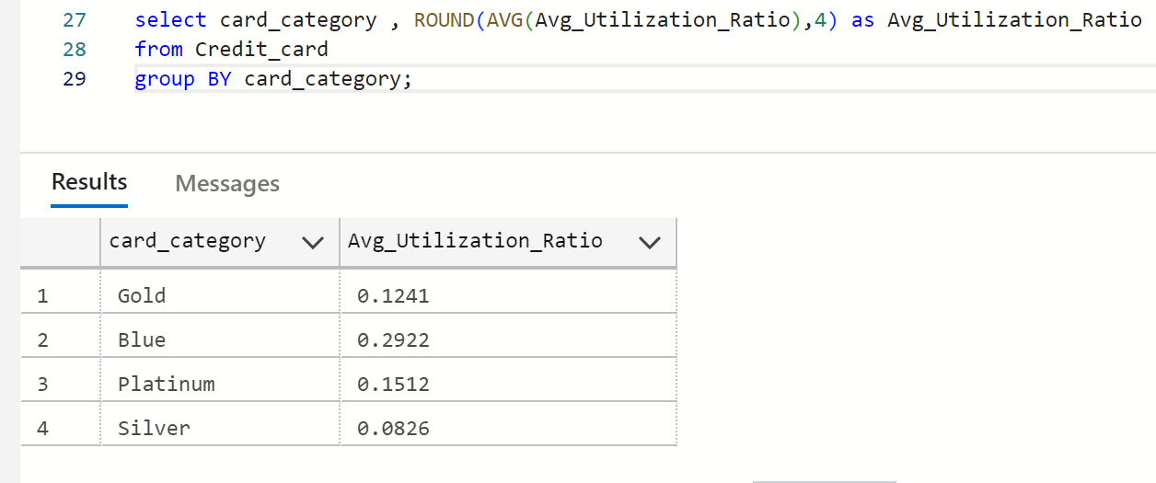

6. Number of Clients Who Activated Within 30 Days

select COUNT(distinct client_Num) as Activated_customers from Credit_card

 WHERE Activation_30_Days =1;

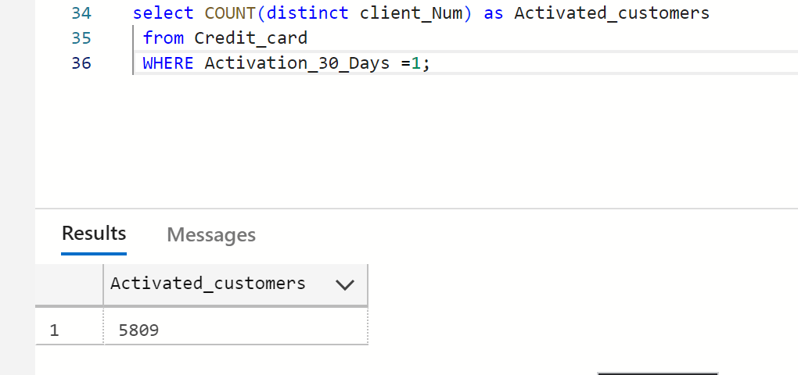

7.Total Transaction Amount and Volume by Expense Type

select Exp_Type,SUM(Total_Trans_Amt) as Total_tran_amount,SUM(Total_Trans_Vol)

as Total_Tran_volume FROM Credit_card group by Exp_Type;

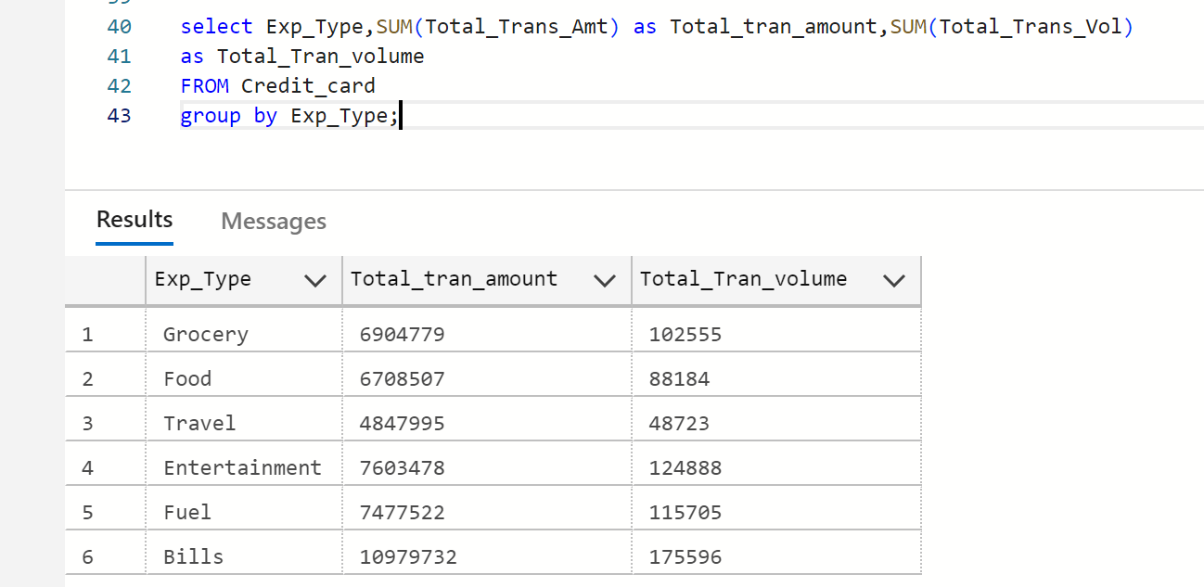

8. Average Credit Limit by Card Category

select card_category, Round(AVG(Credit_Limit),2) as Avg_Creditlimit

from Credit_card group by card_category;

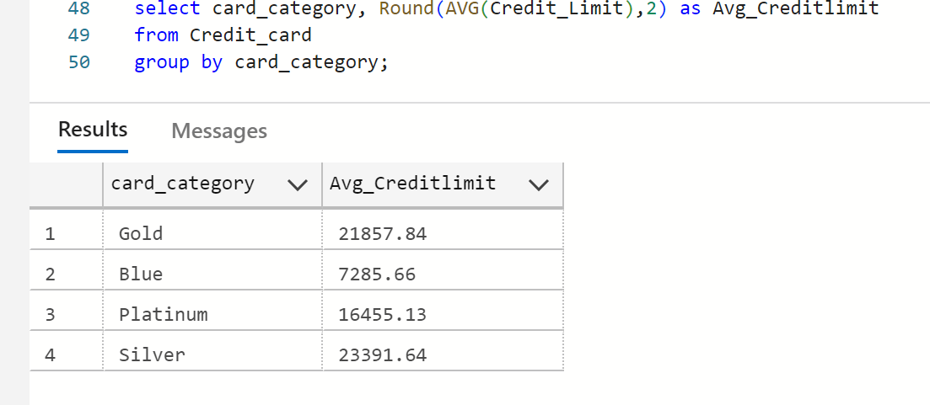

9. Total Revolving Balance by Use Chip (Chip/Swipe/Online)

select Use_Chip, SUM(Total_Revolving_Bal) as Total_Revolving_Bal

from Credit_card GROUP by Use_Chip;

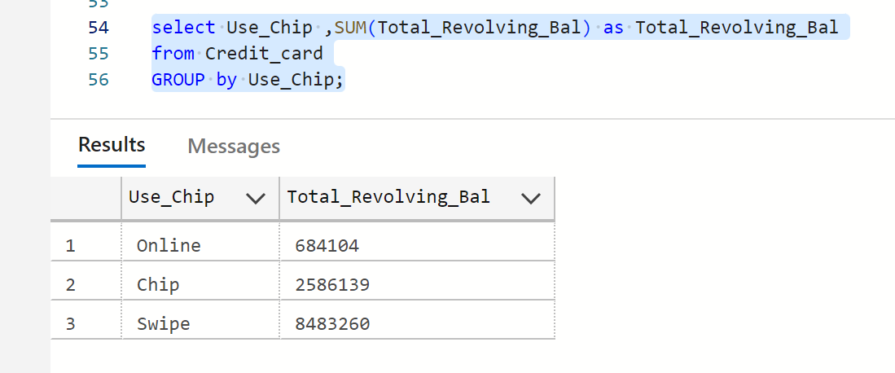

10. Count of Delinquent Accounts by Card Category

select card_category, COUNT(Delinquent_Acc) as Delinquent_Acc

from Credit_card where Delinquent_Acc=1 GROUP by card_category;

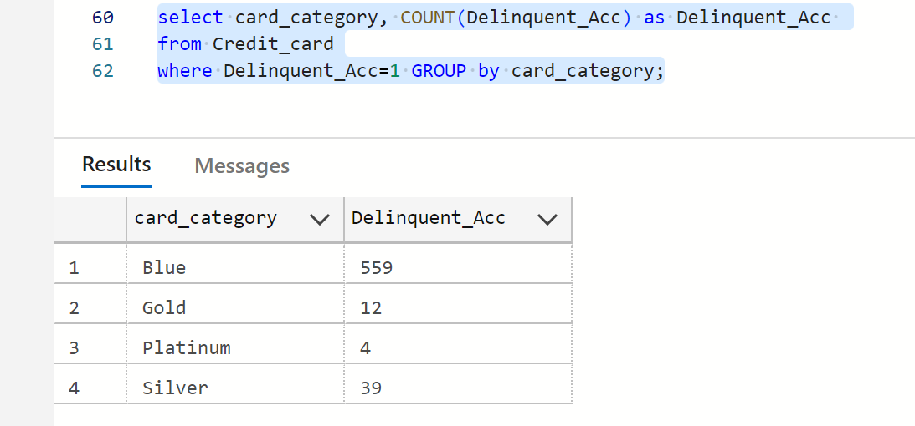

11. Average Interest Earned by Whether the Client Used Chip or Not

select Use_Chip,Round(AVG(Interest_earned),2) as Avg_Interest_earned from

Credit_card group by Use_Chip;

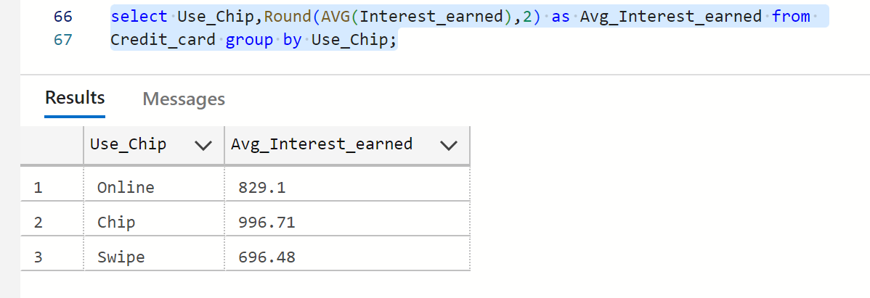

12. Top 5 Clients by Total Transaction Amount

select top 5 client_Num,Total_Trans_Amt as Total_Trans_Amount from

Credit_card ORDER by Total_Trans_Amt DESC ;

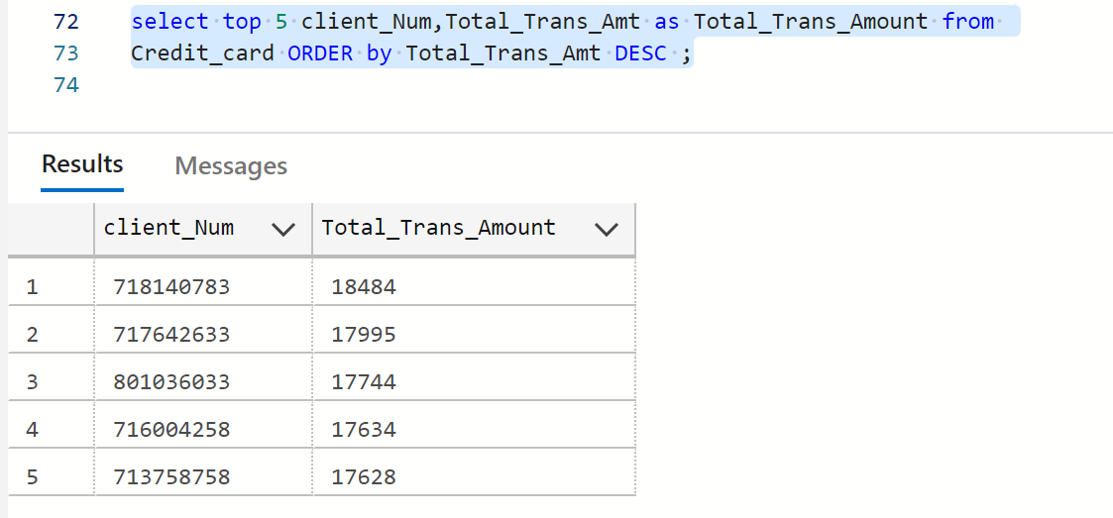

13. Total Customer Acquisition Cost by Card Category

select card_category, SUM(Customer_Acq_Cost) as Customer_Acq_Cost from Credit_card

GROUP by card_category;

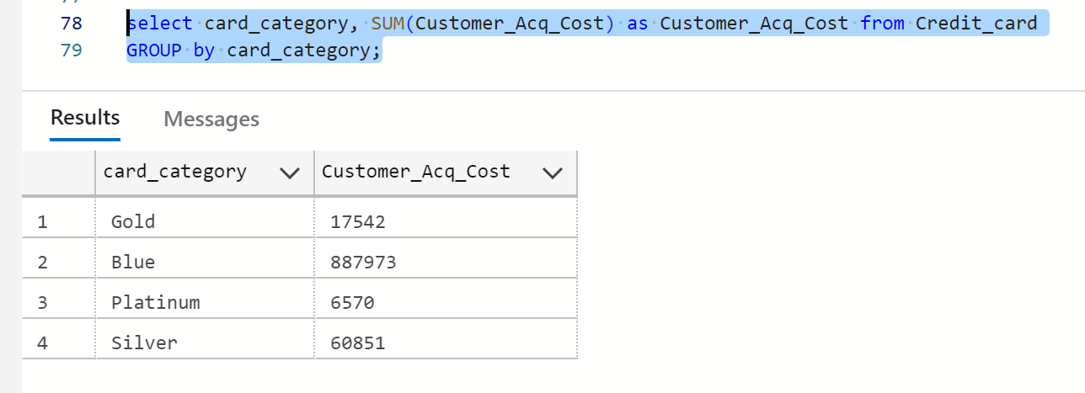

14. Average Total Transaction Volume for Clients with Platinum Cards

select AVG(Total_Trans_Vol) as avg_Total_Trans_Vol from Credit_card

where card_category= 'Platinum';

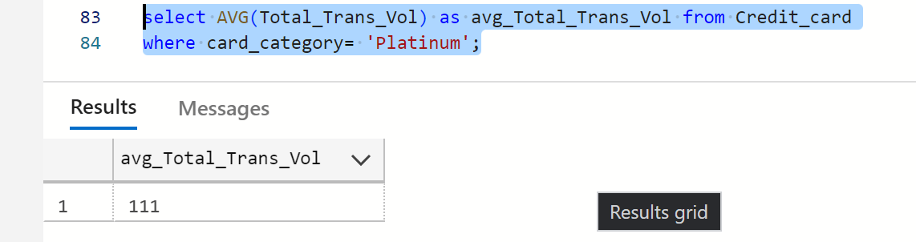

15. Average and Total Credit Limit for Clients with a Delinquent Account

select Round(AVG(Credit_Limit),2) as avg_Credit_Limit,Round(SUM(Credit_Limit),2) as Total_Credit_Limit from Credit_card where Delinquent_Acc= 1;

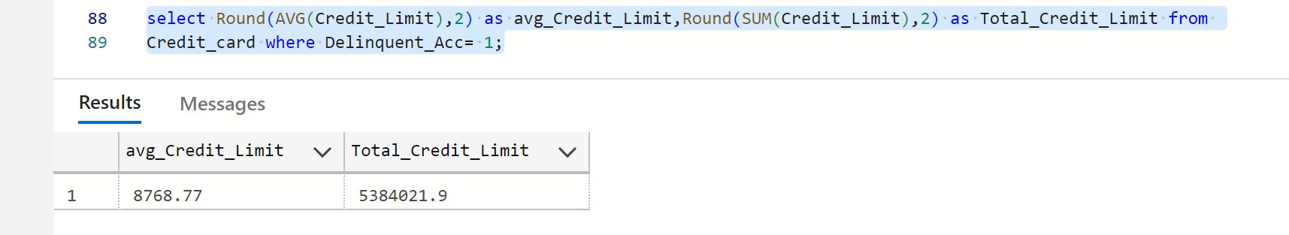

16. Number of Clients by Week Number

select Week_Num, COUNT(client_Num) as Total_customers from Credit_card

group by Week_Num;

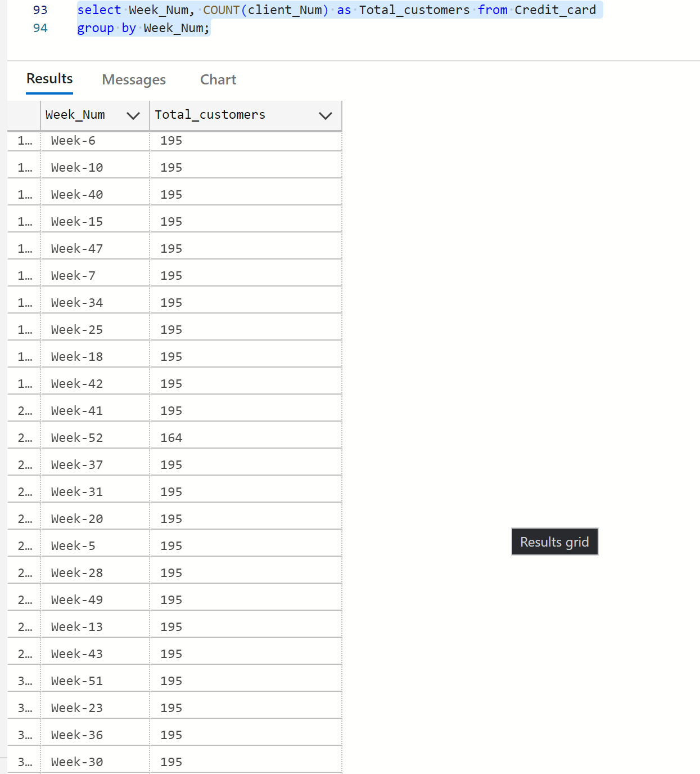

17. Total Interest Earned by Week Number

select Week_Num, SUM(Interest_earned) as Total_Interest_earned from Credit_card

group by Week_Num;

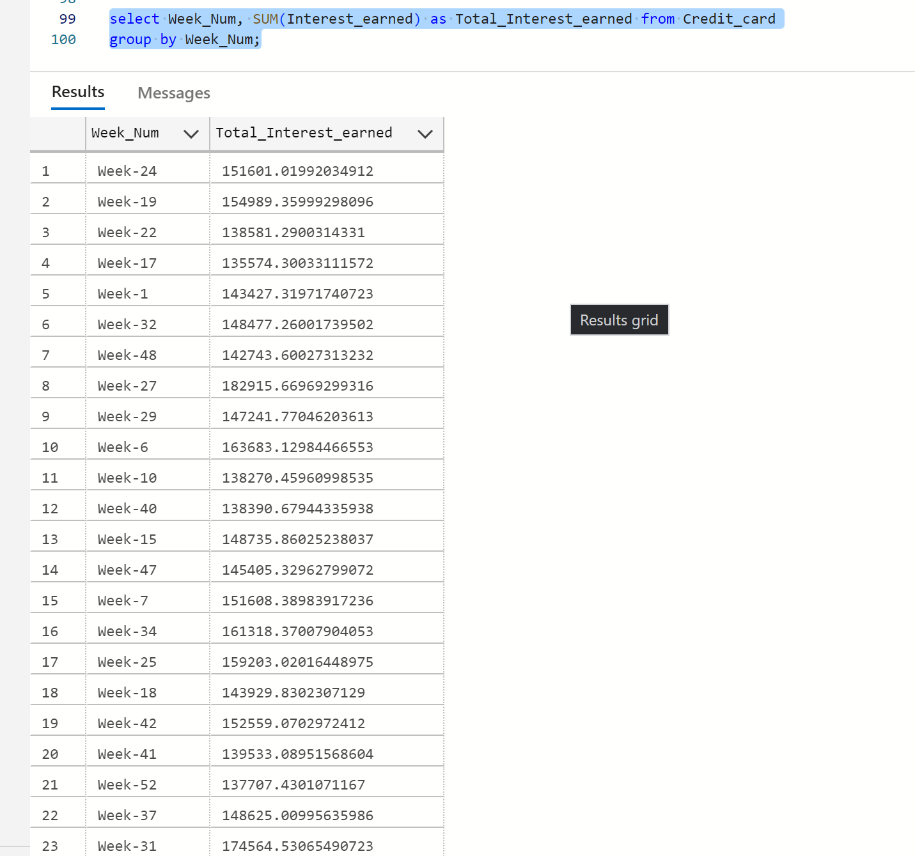

18. Count of Clients with High Utilization Ratio (>0.5)

select COUNT(client_Num) as Customers_count from Credit_card where Avg_Utilization_Ratio > 0.5;

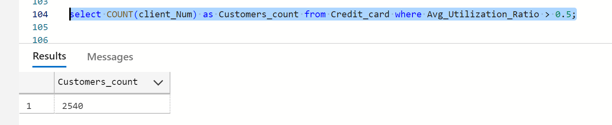

19. Average Customer Acquisition Cost by Week

select Week_Num, AVG(Customer_Acq_Cost) as Customer_Acq_Cost from Credit_card

group by Week_Num;

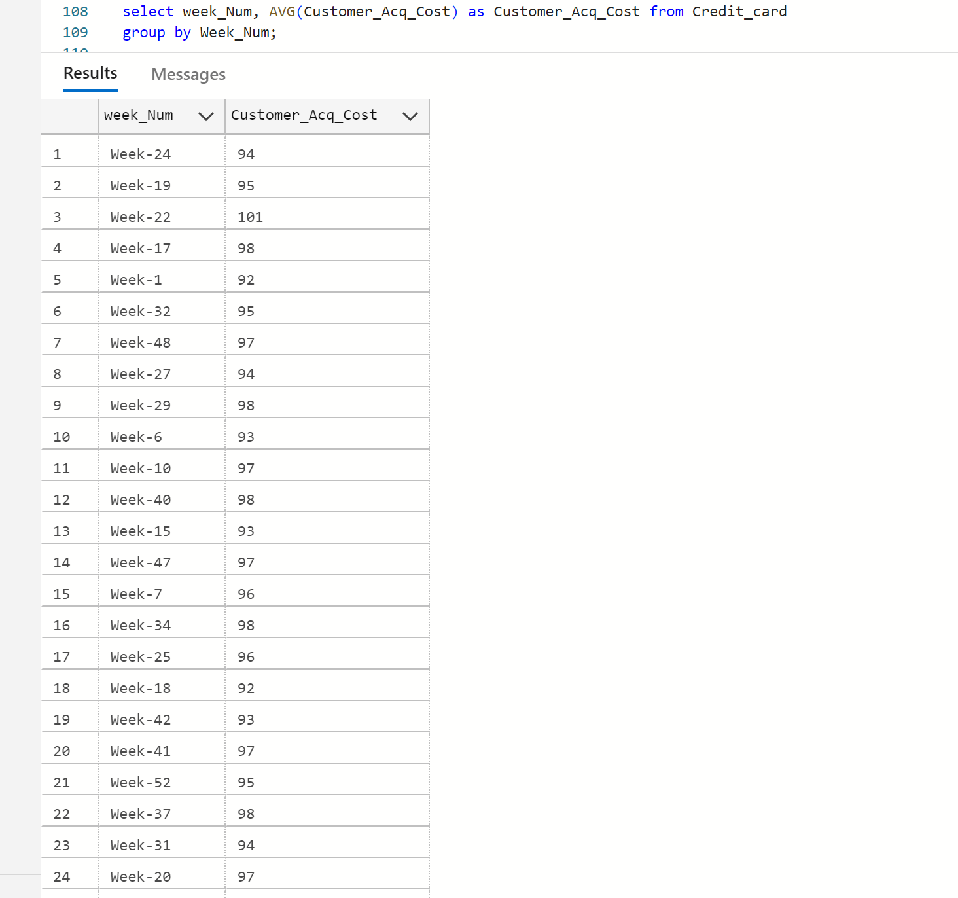

20. Total Transaction Amount by Expense Type for Clients with Delinquent Accounts

select Exp_Type, SUM(Total_Trans_Amt) as Total_Trans_Amt from Credit_card where Delinquent_Acc=1 group by Exp_Type;

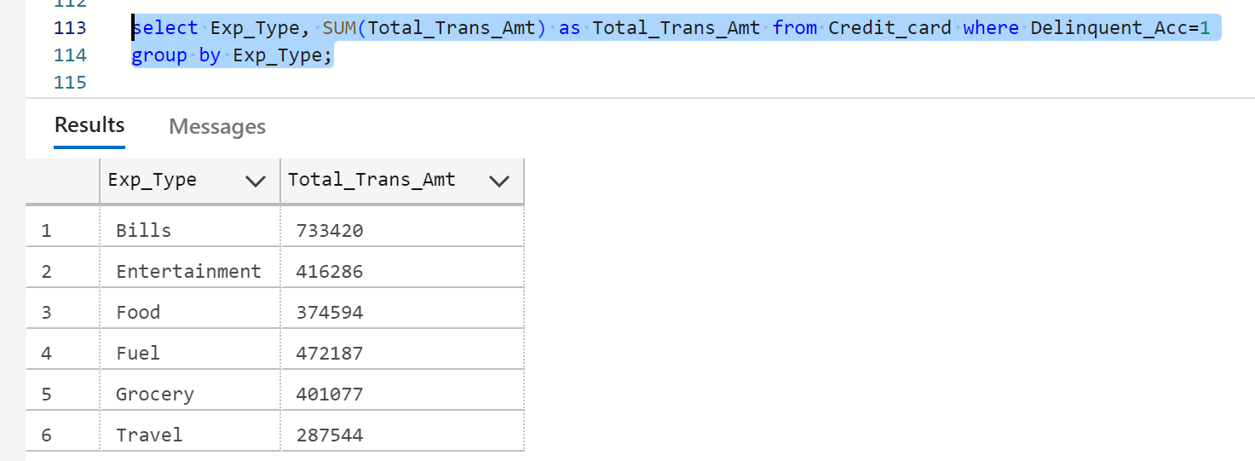

21. Customer Average Income by Card Category

select cc.Card_Category, AVG(c.Income) as avg_Income from Credit_card cc

join Customer c on cc.client_Num=c.client_Num group By cc.Card_Category;

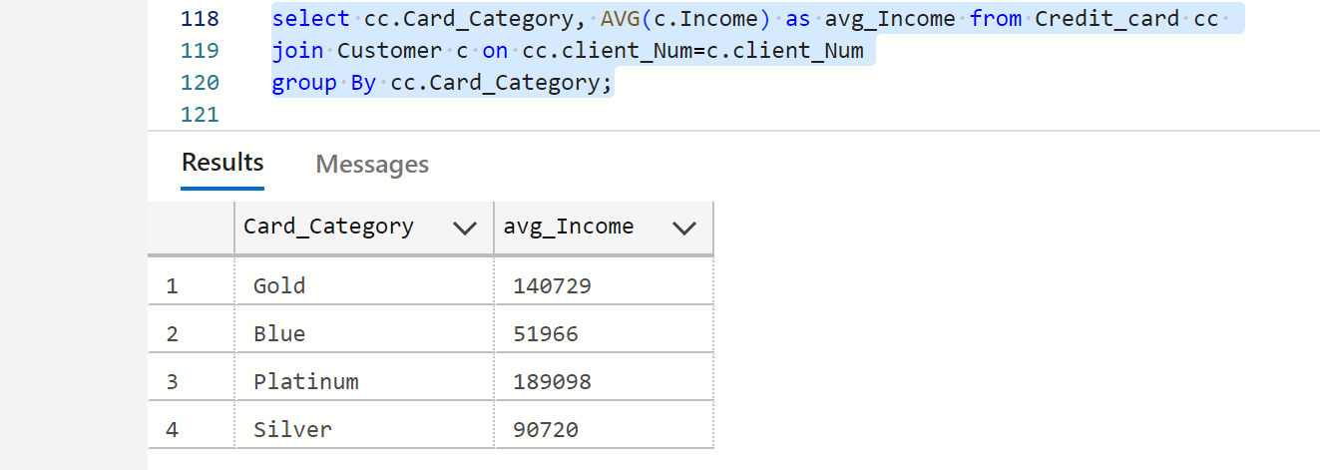

22. Customer Satisfaction Score by Card Category

select cc.Card_Category,avg(c.Cust_Satisfaction_Score) as Customer_Satisfaction_Score  from Customer c join

Credit_card cc on cc.client_Num=c.client_Num group By cc.Card_Category;

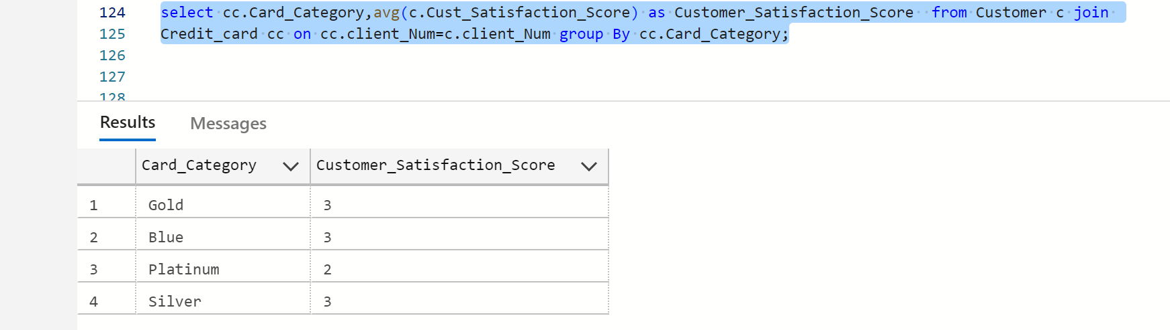

23. Total Interest Earned by Gender

select c.Gender, Round(SUM(cc.Interest_Earned),2) as Total_Interest_Earned from Credit_Card cc join Customer c

on cc.client_Num=c.client_Num group by c.Gender;

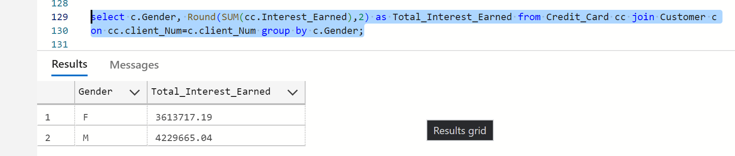

24. Number of Delinquent Accounts by Education Level

select c.Education_Level,count(cc.Delinquent_Acc) as Delinquent_Accounts from Credit_Card cc join

Customer c on cc.client_Num=c.client_Num where cc.Delinquent_Acc = 1 group by c.Education_Level;

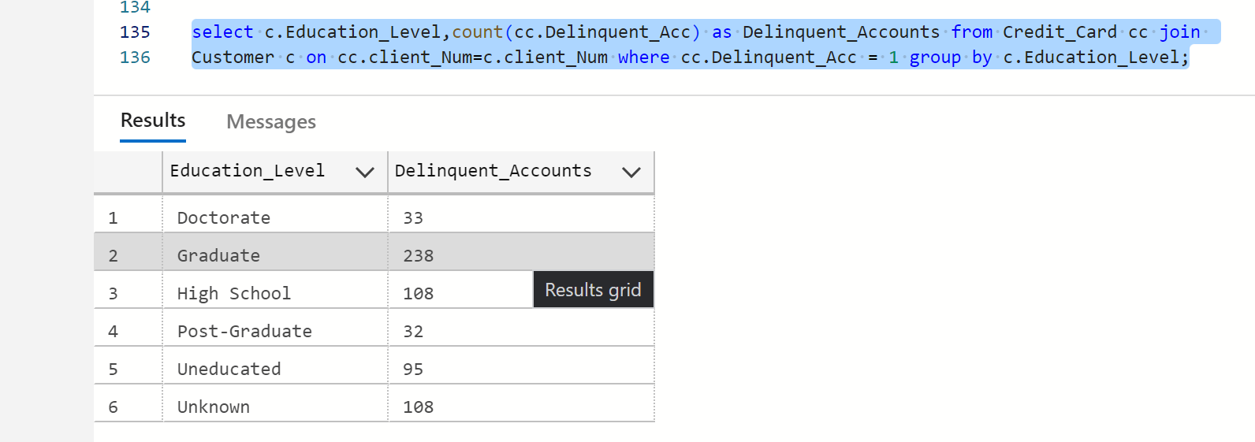

25. Total Transaction Amount by Job Type

select c.Customer_Job, SUM(cc.Total_Trans_Amt) as Total_Trans_Amt from Credit_Card cc join

Customer c on cc.client_Num=c.client_Num group By c.Customer_Job;

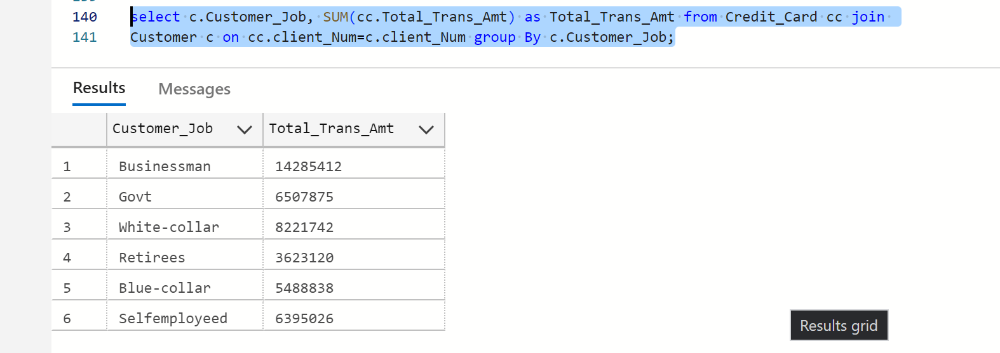

26. Total Transaction amount by Gender and Job Type

select c.Gender, c.Customer_Job,ROUND(SUM(cc.Total_Trans_Amt),2) as Total_Trans_Amount from Credit_Card cc join Customer c on cc.client_Num=c.client_Num group by c.Gender,c.Customer_Job;

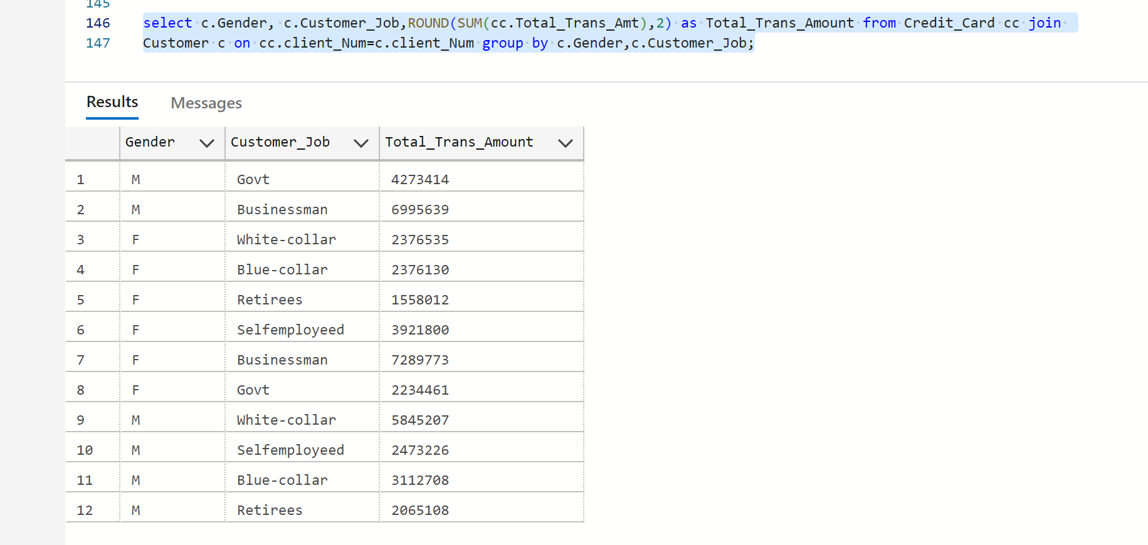

27. Customers by Gender

select Gender,count(distinct client_Num) as Total_Customers from Customer GROUP by Gender;

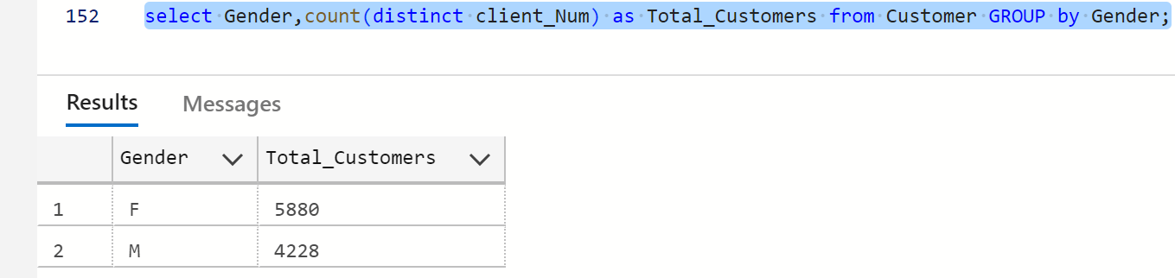

28. Top 5 Customers by Age

select top 5 Customer_Age, count(distinct client_Num) as Total_Customers from Customer

group by Customer_Age order by Total_Customers DESC;

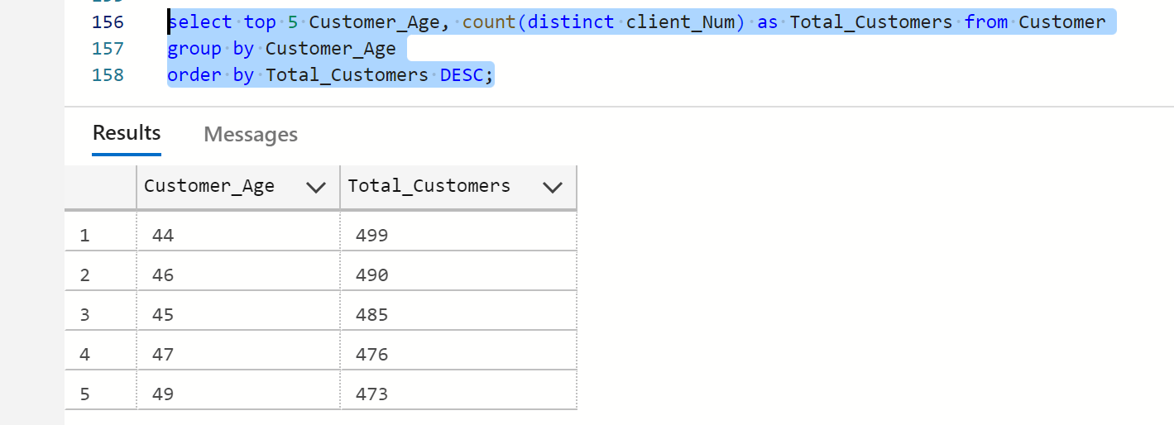

29. Customers by job type

select Customer_Job, count(distinct client_Num) as Total_Customers from Customer

GROUP by Customer_Job;

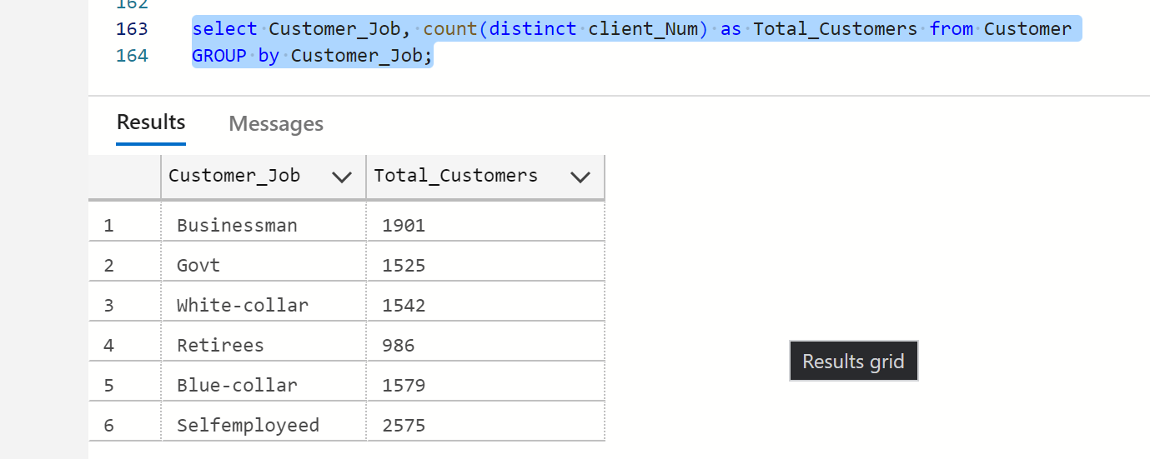

30. Customers by Marital Status

select Marital_Status,count(distinct client_Num) as Total_Customers from Customer

GROUP by Marital_Status;

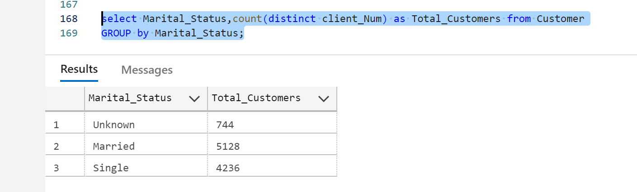

31. Customers by Education Level

select Education_Level,count(distinct client_Num) as Total_Customers from Customer

GROUP by Education_Level;

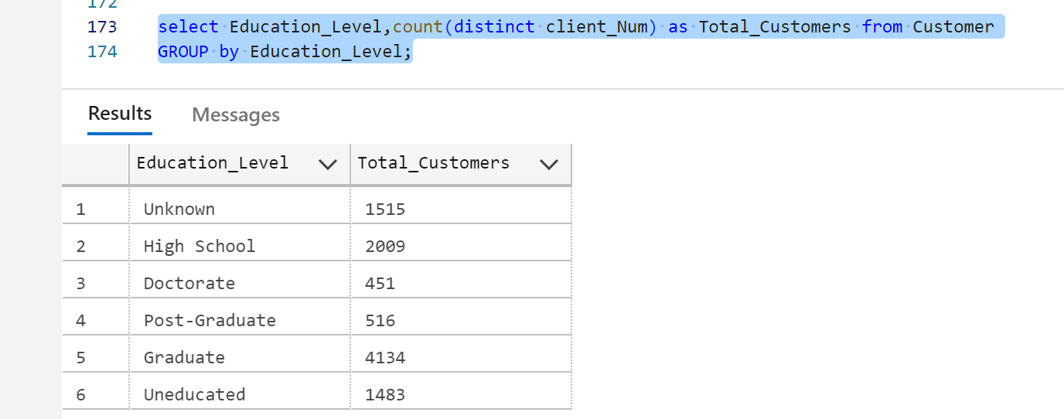

32. Number of Customers Having House and Car

select count(distinct client_Num) as Total_Customers from Customer where Car_Owner=1 and House_Owner=1;

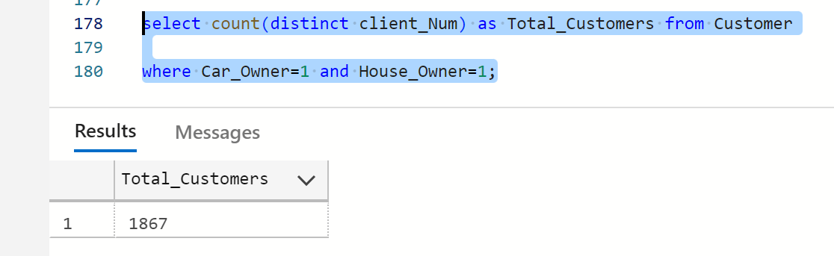

33. Top 5 Customer age Having High Income

select top 5 Customer_Age, sum(Income) as Income from Customer group by Customer_Age

ORDER by Income DESC;

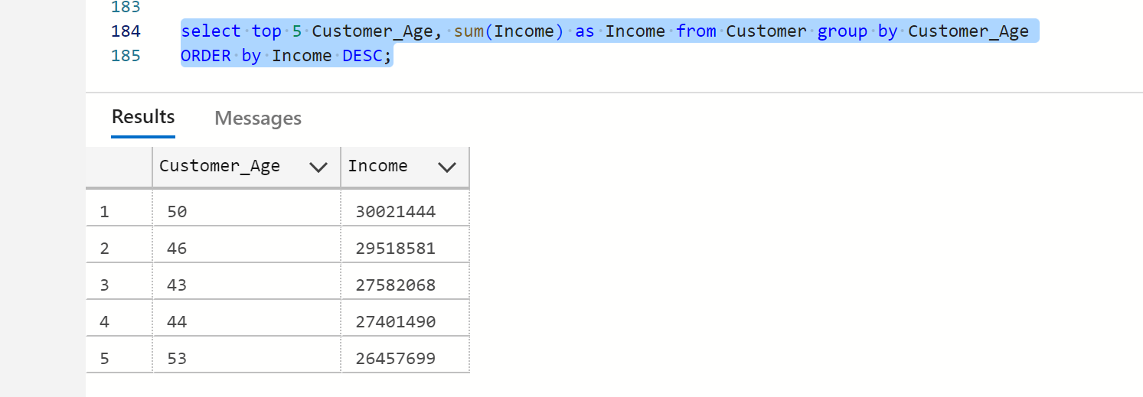

34. Top 3 Average Customer satisfaction Score by Gender, Job Type, Education, Marital Status

select top 3 Gender,Customer_Job,Education_Level,Marital_Status,AVG(Cust_Satisfaction_Score) as Customer_Statisfaction_Score from Customer group by Gender,Customer_Job,Education_Level,Marital_Status ORDER by Customer_Statisfaction_Score desc;

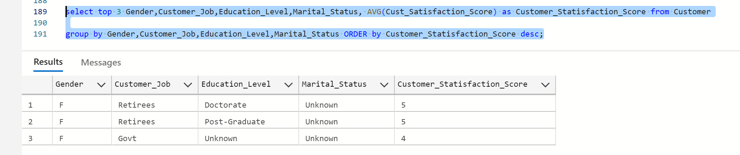

35. Monthly average Interest Earned and Total Interest earned

select FORMAT(Week_Start_Date,'MMMM') as Month_name , round(AVG(Interest_Earned),2) AS Avg_Interest_Earned ,ROUND(sum(Interest_Earned),2) as Total_Interest_Earned

from Credit_Card GROUP BY FORMAT(Week_Start_Date,'MMMM');

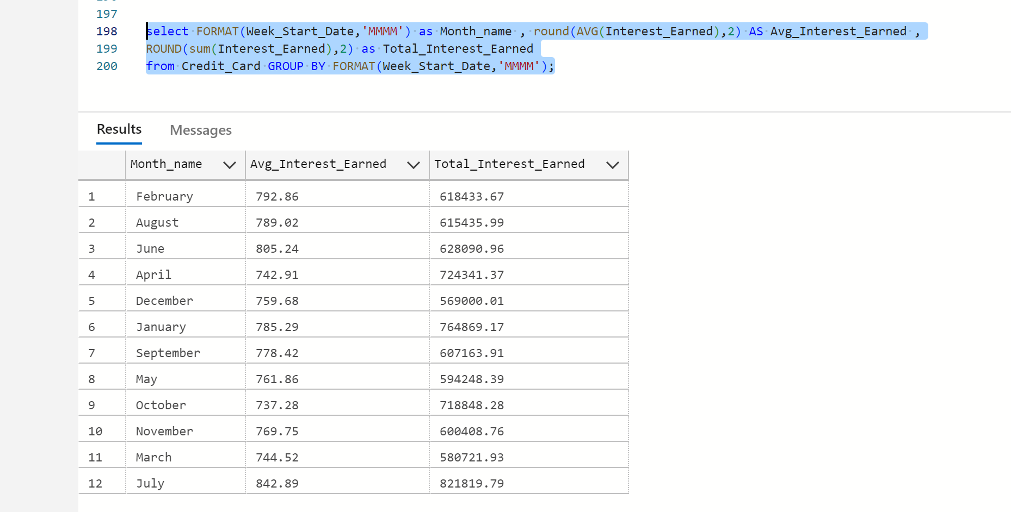

36. Customer Transactions by Expense Type and Job Type

select c.Customer_Job,cc.Exp_Type,sum(cc.Total_Trans_Amt) as Total_Trans_Amt from Credit_Card cc JOIN

Customer c on cc.client_Num=c.client_Num group by c.Customer_Job,cc.Exp_Type;

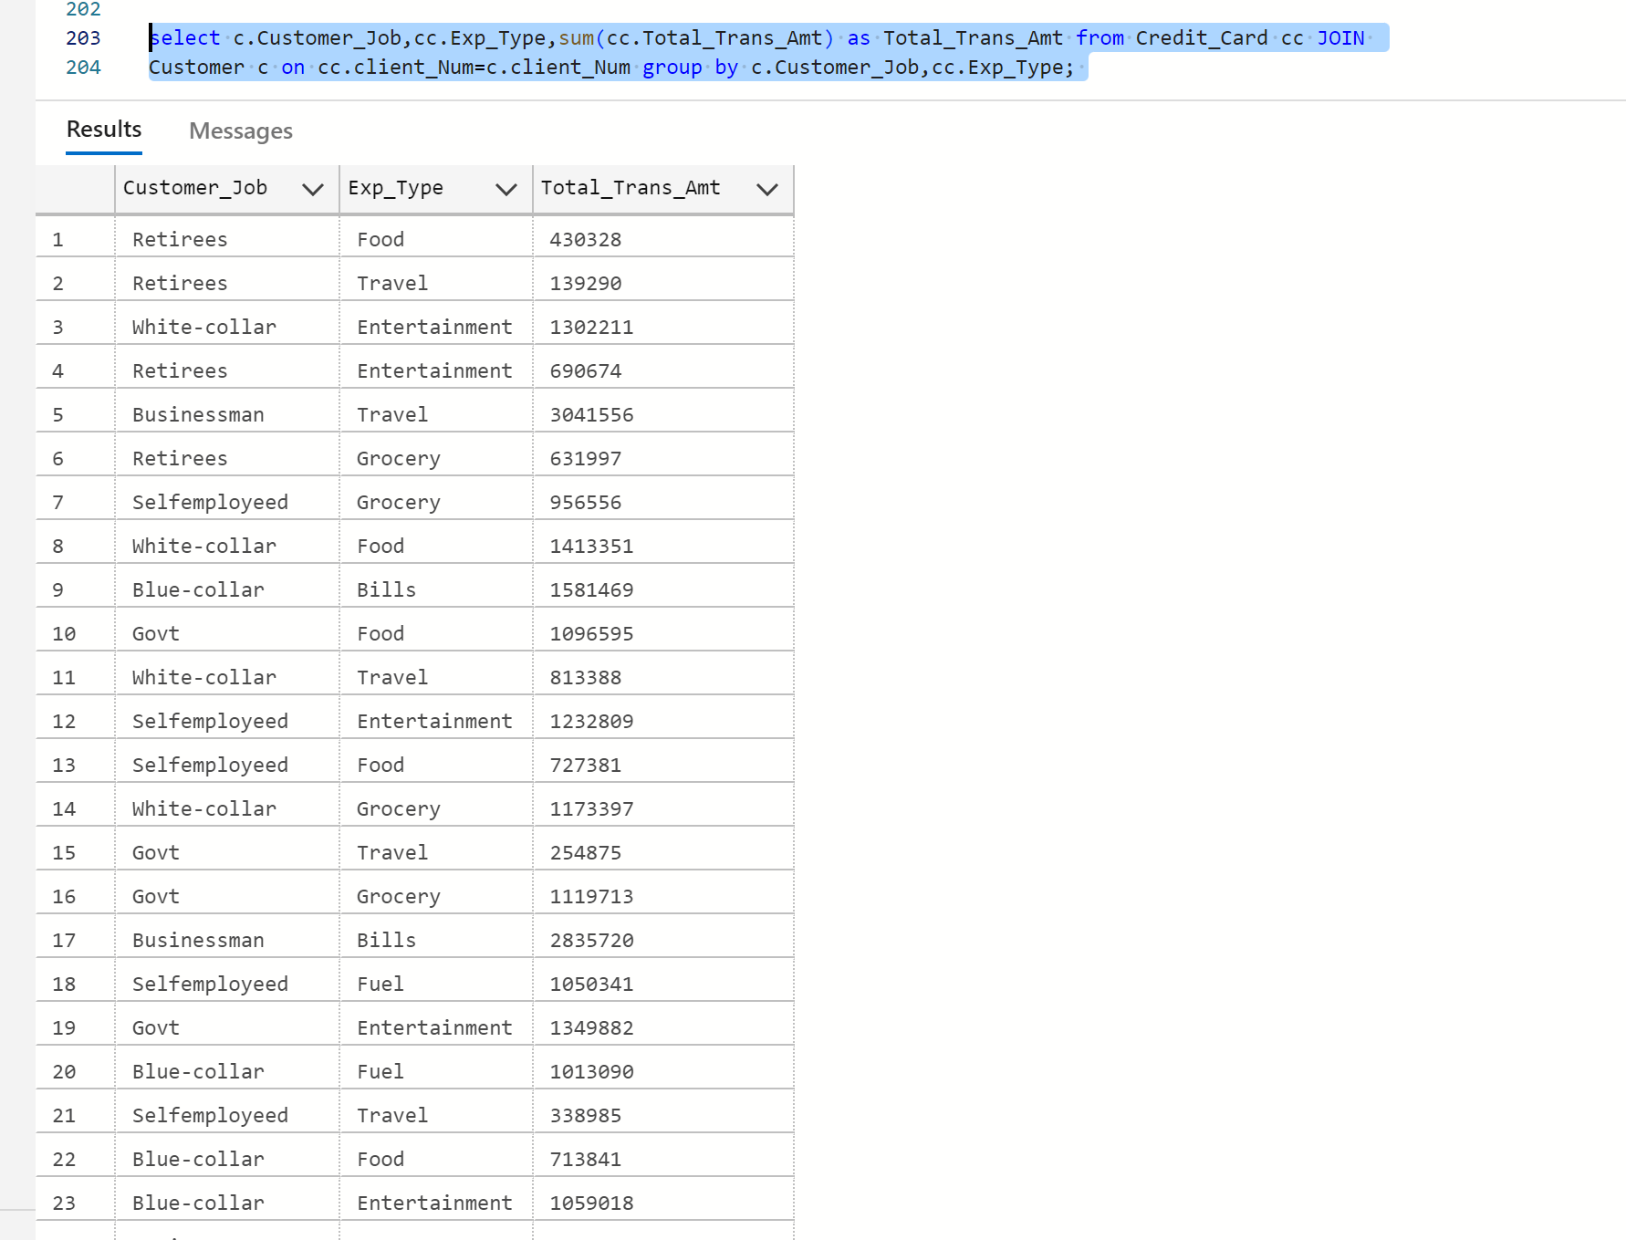

37. Top card Avg_Utilization_Ratio by Customer age

select top 5 c.Customer_Age,Round(AVG(cc.Avg_Utilization_Ratio),3) as Avg_Utilization_Ratio from Credit_Card cc join

Customer c on c.client_Num=cc.client_Num group by c.Customer_Age order by Avg_Utilization_Ratio DESC;

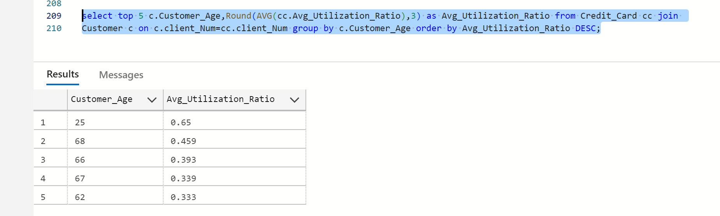

38. Transaction Amount and Interest Earned by Quarter

select Qtr, ROUND(sum(Total_Trans_Amt),2) as Total_Trans_Amount, ROUND(sum(Interest_Earned),2) as Interest_earned from Credit_Card GROUP by Qtr;

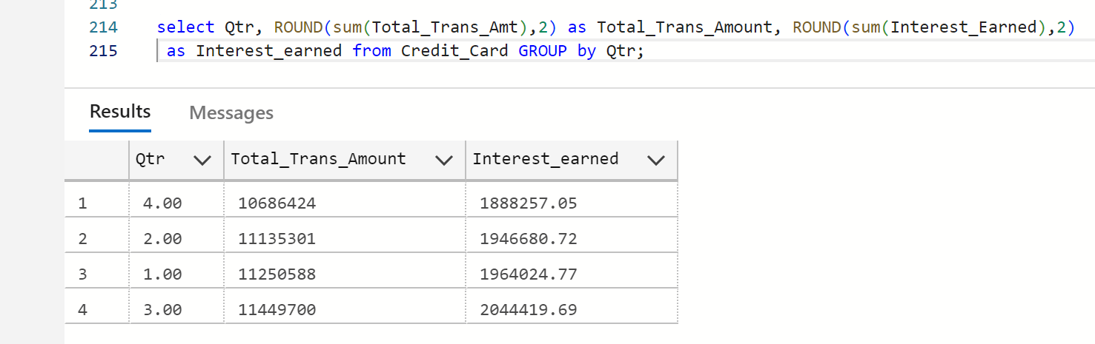

39. Transaction Amount and Interest Earned by Customer Personal Loan

select c.Personal_loan, ROUND(sum(cc.Total_Trans_Amt),2) as Total_Trans_Amount, ROUND(sum(cc.Interest_Earned),2) as Interest_earned from Credit_Card cc join Customer c on c.client_Num=cc.client_Num group by c.Personal_loan;

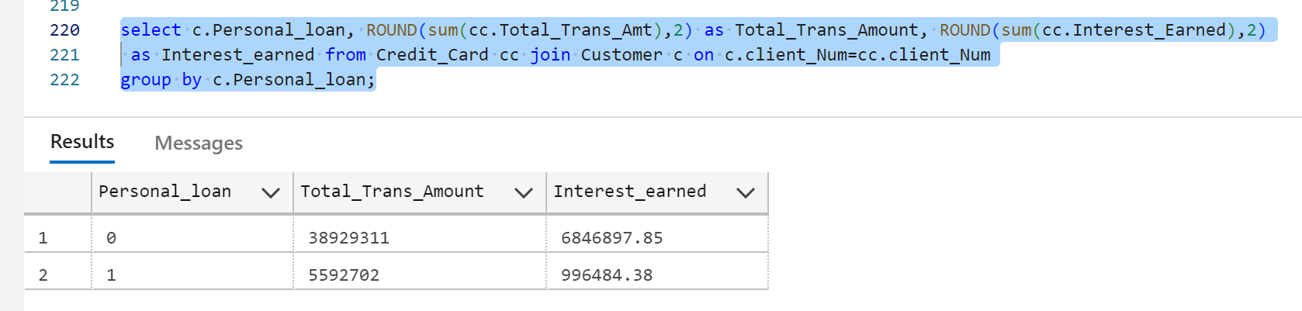

40. Monthly Revolving Balance Distribution

select FORMAT(Week_Start_Date,'MMMM') as Month_Name, ROUND(sum(Total_Revolving_Bal),2) as Total_Revolving_Bal from Credit_Card GROUP by FORMAT(Week_Start_Date,'MMMM');

